Netflix Executive Business Insights Report
Prepared by Arshiya Ahmed, Business Analytics Intern, Auspify Technologies

1. Purpose
This report brings together the findings from five analyses of the Netflix content dataset (8,790 titles). It gives Netflix leadership clear recommendations for content planning and market growth.

2. Key Business KPIs
KPI | Value
Total titles in library | 8,790
Movies share | 70% (6,126 titles)
TV shows share | 30% (2,664 titles)
Top market | United States, 3,240 titles (about 38%)
Second market | India, 1,057 titles (about 12%)
Largest audience rating | TV-MA, 3,205 titles
Peak release year | 2018, 1,146 titles
Largest genre | Dramas, 1,599 titles

3. Summary of Insights
Content portfolio (Task 1). Netflix is mainly a movie library. Movies make up 70% of titles and TV shows 30%.
Global markets (Task 2). The United States and India together hold about half of all titles. The UK, Pakistan, Canada, Japan and South Korea follow.
Audience segmentation (Task 3). Most content is for mature audiences (TV-MA and TV-14). Kids' content is a small share. In kids' ratings, Netflix has more TV shows than movies, which is the opposite of the overall pattern.
Growth over time (Task 4). The library grew slowly for decades, then quickly after 2015. Releases peaked in 2018 and then fell, likely because of COVID-19 production pauses. The 2021 data is also incomplete.
Content categories (Task 5). Dramas, Comedies, Action & Adventure and Documentaries are the largest genres.

4. Opportunities and Challenges
Opportunities
- Kids' and family content is underserved, and children prefer series.
- India is a large, growing market with strong existing content.
- Dramas and Comedies are proven, popular categories.
Challenges
- New releases have slowed since the 2018 peak.
- Heavy dependence on mature content may limit appeal to families.
- The library is concentrated in a few countries.

5. Visualizations
- Pie chart: Movies vs TV Shows (Excel)
- Bar chart: Top 10 Countries by Content (Excel)
- Column chart: Content by Rating, Movies vs TV Shows (Excel)
- Line chart: Netflix Growth Over Time (Tableau Public)
- Interactive dashboard: Content by Genre with Movie/TV Show filter (Tableau Public)
Figure 1. Task 1: Movies vs TV shows (Excel)
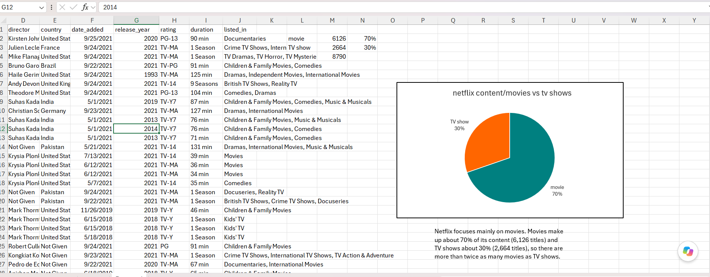
Figure 2. Task 2: Top 9 countries by content (Excel)
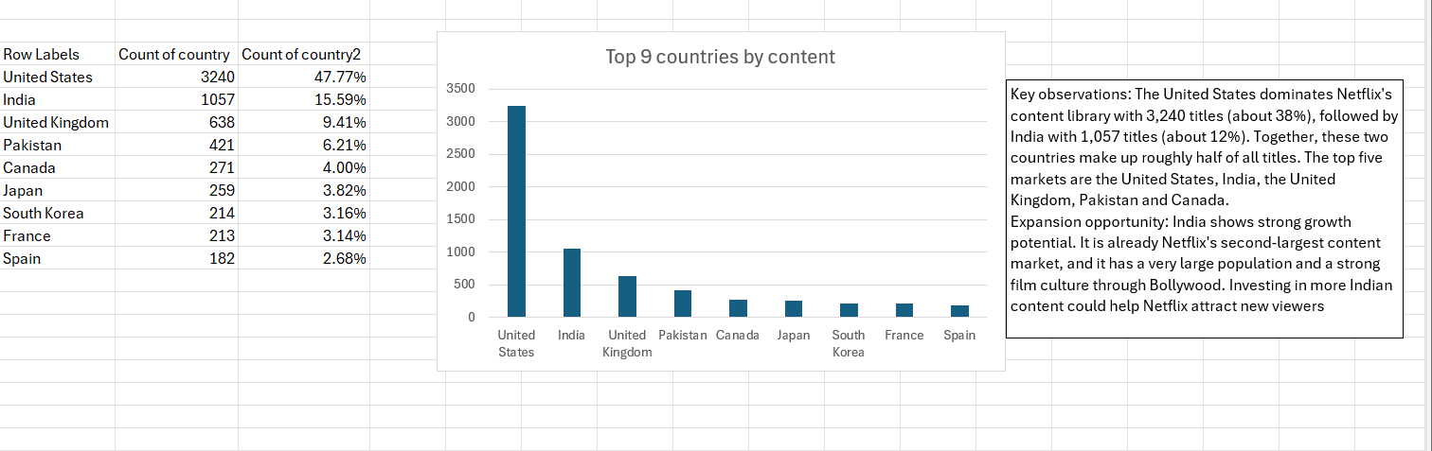
Figure 3. Task 3: Content by rating, movies vs TV shows (Excel)
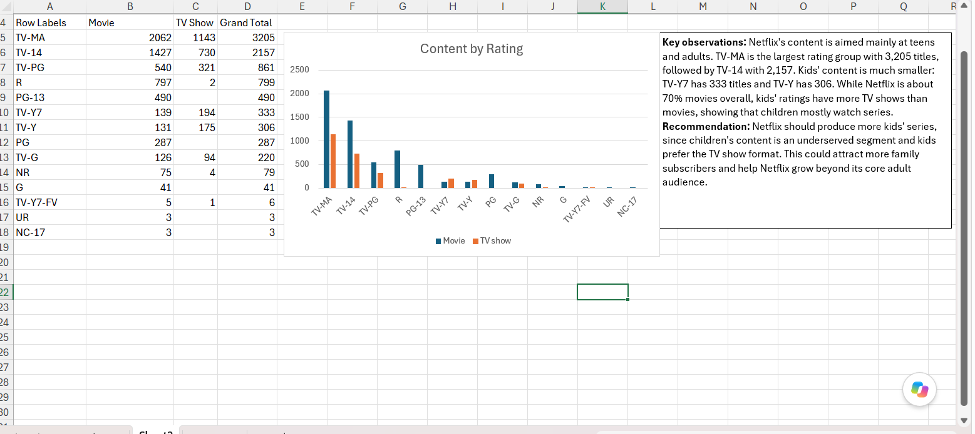
Figure 4. Task 4: Netflix growth over time (Tableau)
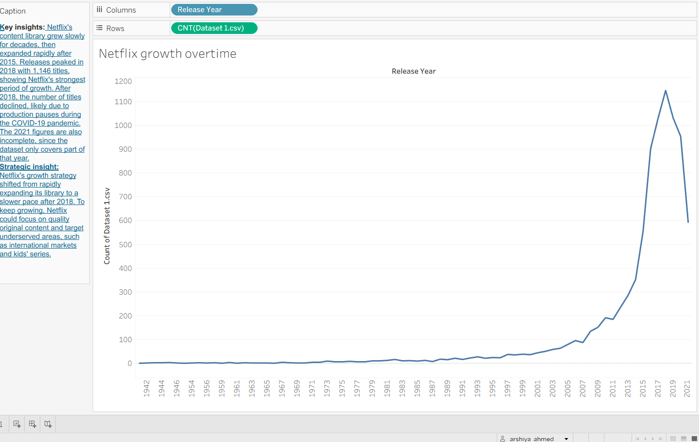
Figure 5. Task 5: Content category performance dashboard (Tableau)
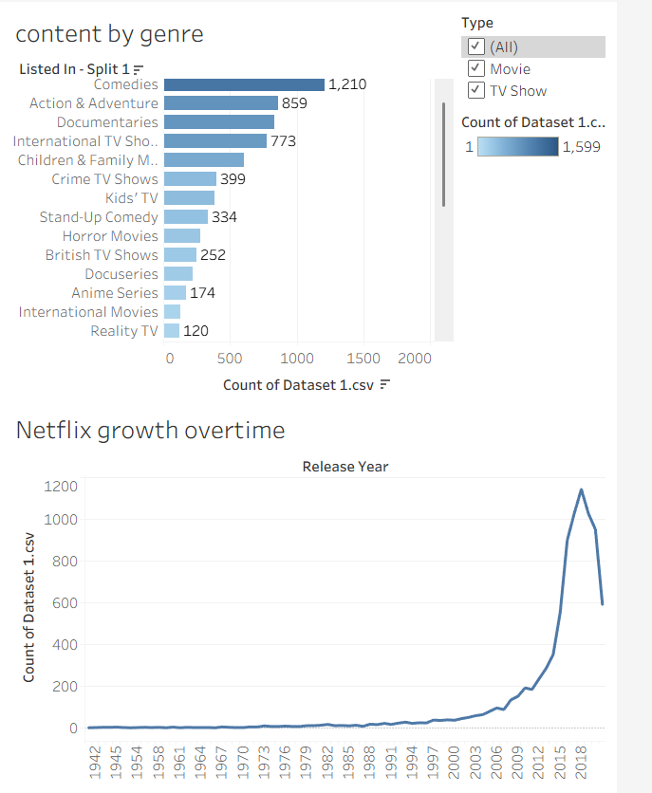

6. Recommendations
- Grow kids' and family series to reach an underserved audience.
- Expand in India with more local and regional content.
- Keep investing in Dramas and Comedies, the strongest categories.
- Restore release growth by focusing on quality original content after the post-2018 decline.
- Diversify markets beyond the US and India to reduce concentration risk.

7. Conclusion
Netflix has a large, movie-led library focused on mature audiences in a few major markets. Growing family content, expanding in India, and rebuilding release growth would support long-term growth.

